HW1 -Part3 Report

1. Create a collection called ‘games’

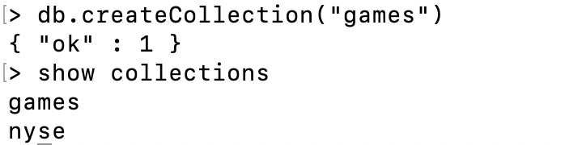

1. Add 5 games to the database. Give each document the following properties: name, genre, rating (out of 100)



1. If you make some mistakes and want to clean it out, use remove() on your collection.

1. Write a query that returns all the games.

1. Write a query to find one of your games by name without using limit().

1. Use the findOne method.

1. Write a query that returns the 3 highest rated games.



1. Update your two favorite games to have two achievements called ‘Game Master’ and ‘Speed Demon’, each under a single key.
2. Using update()

1. Using save().





1. Write a query that returns all the games that have both the ‘Game Master’ and the ‘Speed Demon’ achievements.

1. Write a query that returns only games that have achievements.

